WESTHILL HIGH SCHOOL
MARCHING BAND
2015 Parents’ Guide

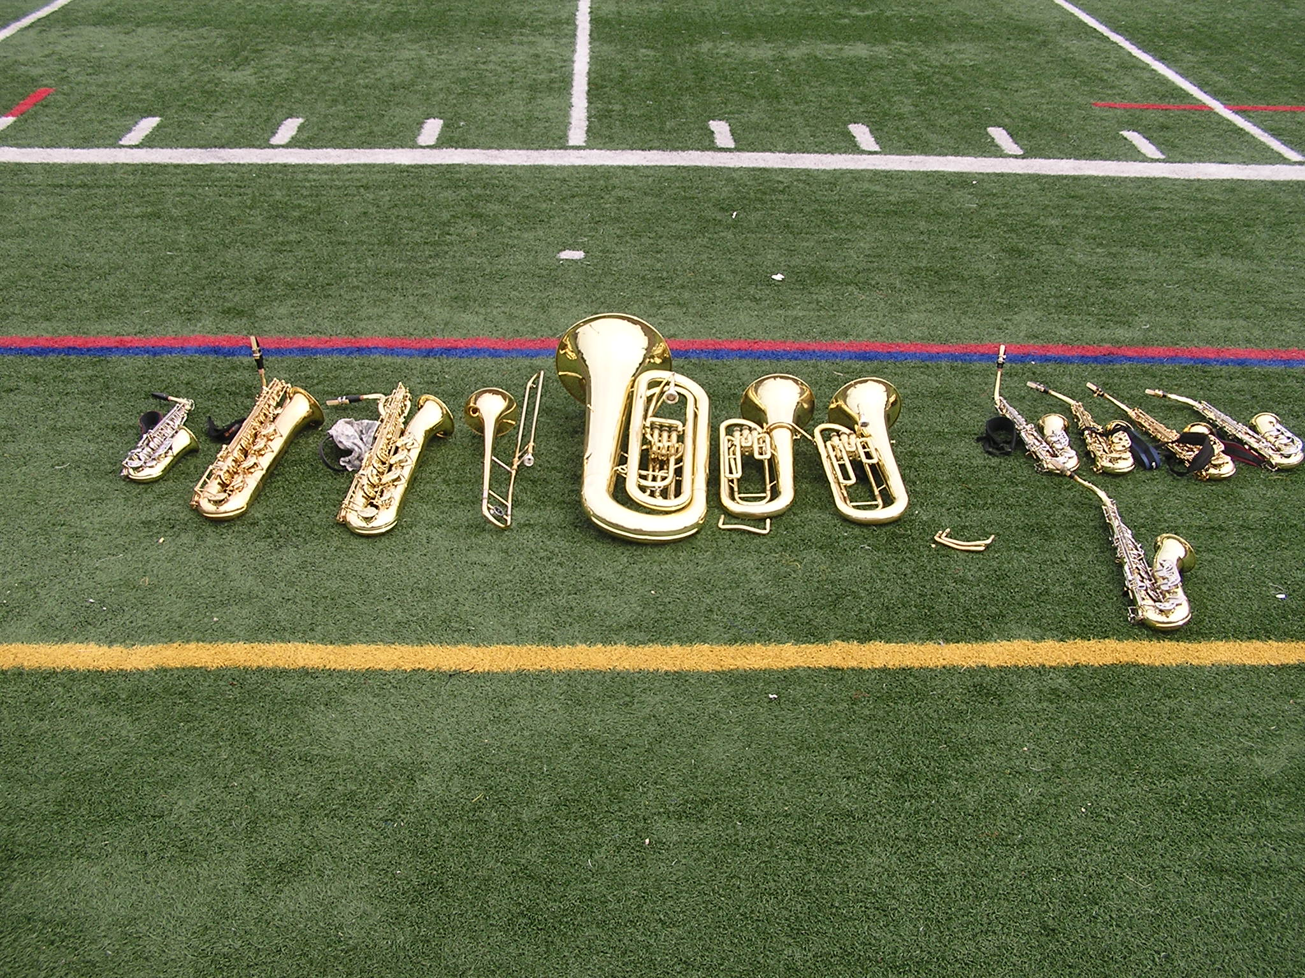

Contents

WELCOME! 3
2015/2016 Westhill Band Parents Association Board Officers and Band Director 4
Marching Band Code of Conduct 6
DATES for PARADES and COMPETITIONS 7
What to expect - General 8
What to expect - Competition Days 11
Webpage for WHS Instrumental Programs 13
WHY FUNDRAISING MATTERS 17
2015/2016 FUNDRAISERS 18
HOW TO VOLUNTEER: SignUpGenius 19

WELCOME!

Dear Parents:
We would like to welcome you to the Fall 2015 Westhill Marching Band season!
This handbook should provide answers to most questions you may have regarding the Marching Band program. It will provide the schedule of practices and competitions; dates for other Marching Band events; payment and other responsibilities of Marching Band members; and fundraising information. It will also tell you how to access our website for up-to-date information and how to sign up to volunteer throughout the season by using our SignUpGenius account.
This handbook also provides the contact information for the Westhill Band Parent Association members. Please do not hesitate to contact if you have any questions or concerns.

Sincerely,

The Westhill Band Parent Association Board

2015/2016 Westhill Band Parents Association Board Officers and Band Director

Officer (son/daughter in band)
CO-PRESIDENTS Convene meeting, coordinate schedules, coordinate sale of grocery cards and gift cards, post schedule on website; set up SignUpGenius for snacks, chaperones, etc.

Marilyn Johnston (Danny) mrsjohn99106@yahoo.com
59 Long Hill Dr. H: 203-975-2986 C: 203-252-1682

Wendy Lecker (Noah Schafer) wendylecker@aol.com
98 Larkspur Rd. H: 203-329-8041 C: 203-536-7567

CO-TREASURERS Collecting money, keeping student accounting records, paying band bills, etc.

Tanya Kelley (Kayla) ttsmiles247@gmail.com
95 Morgan St. #6E C: 203-309-9329

Meade-Love Thomas (Greg Penn) mlthomas1967@gmail.com
4 Elizabeth Ave H: 203-325-8355 C: 203-554-7861

SECRETARY Recording and circulating minutes from meetings; other administrative duties

Mary Janocha (Chris) merrycj1@aol.com
23 Skyline Lane H: 203-329-9344 C: 203-962-2395

FUNDRAISING Mixed Bag, candy sales, other fundraisers

Dianne Houtz (Carolyn) houtzdf@yahoo.com
128 Apple Valley Road H: 203-461-8829 C: 203-561-7332

Joan Bellantoni (Nick) jbella9488@gmail.com
239 Fishing Trail H: 203-968-0150 C: 203-943-4993

MEMBERSHIP in Westhill Band Parents Association: All parents are members!
Please watch for announcements of meetings, and attend as many meetings as possible, in order to learn what to expect from rehearsals and competitions, how the band is doing financially, what fundraisers are in progress and around the corner, etc. It’s also your chance to ask questions, if you are feeling in the dark!

BAND DIRECTOR
Michael Wyatt mywatt@stamfordct.gov
125 Roxbury Road O: 203-977-4426

Parents, please review the season schedule on http://westhillband.weebly.com/ and notify the band director VIA WRITING if a conflict exists (with band camp, practice, competition). Note, it is necessary for the band director to let the chaperones know of any changes to the bus attendees in advance during competition days!

Marching Band Code of Conduct

All students and parents sign and return the text that follows as part of the Marching Band registration process. It is included here for easy reference. It is also available on the Westhill Instrumental Music website.
Westhill High School Instrumental Music Department
CODE OF CONDUCT
The Westhill High School Instrumental Music Department believes that our student performers have a responsibility to provide a positive image to our community and peers at all times, regardless of location (classroom, rehearsal, visiting other schools, etc.). Our performers are expected to conduct themselves in accordance with this code and with the rules and regulations governing the student body at large.
Students are expected to act with respect towards the professional staff, adult chaperones, fellow students, and other ensembles at all times. Performers are expected to exhibit optimal effort, participation, sportsmanship and behavior. They are expected not to engage in behavior that could compromise the safety of themselves or others (e.g. consuming and/or possessing alcohol or drugs, breaking curfew, fighting, vandalism, shoplifting, etc.). Westhill High School and its Instrumental Music Program have a zero-tolerance policy. Violations of this code will result in disciplinary action, up to and including suspension, and possible removal from the program.
The way our performers act in the community is extremely important. As a student performer, you must always represent yourself, your family, your ensemble, Westhill High School, and the City of Stamford with dignity and in a manner in which we can all be proud.

DATES for PARADES and COMPETITIONS

Here are a few important dates: (Go to page 18 for Fundraiser Dates)!
Parents: The Band Parents Association will try to meet at least once a month in the little auditorium TBD.
August 26, Thursday, August 20, 7pm MEET AND GREET WITH WESTHILL HIGH SCHOOL BAND PARENTS ASSOCIATION (WHSBPA) BOARD followed by 7:30 BAND PARENT MEETING (All should attend!)

Practice:
Pre-Camp - Tuesdays in July, Tuesdays/Thursdays in August until August 13: Rehearsal 6-9pm, Rippowam Middle School (July 2015 only)
Band Camp - Monday, August 17 – Friday August 21, & Monday Aug 24 - Thursday August 27: Please see schedule posted on http://westhillband.weebly.com/ for start/end times.
After School: Mondays, 6-8: Percussion and Color Guard, Tuesdays/Thursdays, 4 – 7, Full Band, all Saturdays unless otherwise indicated

Competitions:

August 29 Bridgeport, (TBD)
September 12 Bethel (ACT Test Date)
September 19 Brien McMahon
September 26 Trumbull
October 3 Bunnell (SAT Test Date)
October 10 Newtown
October 17 Norwalk
October 24 MAC Championships @ Brookfield (ACT Test Date)
October 31 New England State Championships (TBD)
November 7 National Championships (SAT Test Date)
November 14 – USBands Cadet Challenge (TBD)

Parades:
October 11 Columbus Day
November 8 Veteran’s Day
November 22 Balloon Parade
May TBD 2016 Memorial Day Parade

Miscellaneous: The Marching Band will play at home football games if it works with our competition schedule
August 26 Convocation
November 26 Stamford vs. Westhill Homecoming Football Game
June TBD 2016 Westhill High School Graduation

Please note, the information and schedules on, http://westhillband.weebly.com/ are CONSTANTLY changing and is utilized for all the instrumental programs (including school musicals/plays as we have so many students participating in multiple programs) so please bookmark the site and check often!

What to expect - General

COSTS, FUNDRAISING AND VOLUNTEERING
- Registration fees for 2015 are $275/student, $200 for each additional sibling. Fees cover costs of registration for competitions, the rental truck to carry equipment to competitions, uniforms, etc.
- Students need “walking money” for competitions. Sometimes they need bagged lunch/dinner (please do not pack glass, or allergic foods, e.g. peanuts). Sometimes we ask everyone for $5 for pizza, etc.
- All students are expected to participate in the St Leo’s Fair (an annual event and our single largest fundraiser for our instrumental programs), and all families are expected to have one adult volunteer for St Leo’s.
- All parents are expected to sign up and volunteer at least two more times (help unload the returning bus, contribute snacks, etc). If you can’t sign up, please come anyway, there is always something you can help with! You will find that volunteering in person lets you see how the band works, and how the students all come together, it is highly rewarding and some parents come repeatedly!
- The Band Parents Board believes all interested students should be able to participate, regardless of family resources/circumstances.
  - TIME: Parents often give rides home to other students, after rehearsals and to/from competition pickups. Please ask any Band Parent Board Member if you are having transportation issues (advance notice preferred!).
  - MONEY: Please consider funding or donating any over-payment to a “band scholarship” – some students are unable to meet the financial requirement, and the Band Parent Association maintains pooled funds to help these students. Even a few dollars can provide a meal on one of the many competitions. (Contact Meade Love and/or Tanya for further information.)
BAND CAMP PREPARATION
- Registration Forms needed for the fall are available on http://westhillband.weebly.com/.
- Please bring completed forms and give them to a WHSBPA Member. Students who have not completed all forms will not be able to attend marching band events; Band Parent board members will follow up with students and parents to ensure all forms are filed and complete.
- Band camp is usually the 2 weeks prior to the start of school generally from 9 am to 8 pm. The majority of the music and visuals are learned here and students will be fitted for uniforms/costumes as well. During this time the marching visuals and music are put together. Provide lunch and dinner - the times will be posted if you would like to drop off meals. Your musicians will experience both discipline and fun during their day!
- Recommended:

- sneakers
- hat
- water/drinks
- suntan lotion
- bug spray

GOOD TO KNOW
- Rehearsal end time is when Mr. Wyatt is finished with the rehearsal. Students still need to put away their instruments, return instruments and all equipment to the band room, etc. prior to dismissal– so please allow a minimum of 15 minutes (and, sometimes longer) after the “end time” before you will be able to pick up your student. If a parent wants to come inside, please wait in the foyer outside the band room, when the door to the band room is closed.
- For any event involving bus transportation, parents and older siblings can help unload the equipment truck. The sooner everything is unloaded, the earlier the dismissal can occur.
- Band Parent meetings are held in the small auditorium to the right after the doors past the principal’s office.
- Information is often sent home through the students, however, it is best to receive your information directly via email. Please make sure we have your updated e-mail or inform a Band Parent Board Member if you wish to receive updates via a different method.

UNIFORMS
- Students will be fitted for a uniform (pants, jacket, helmet, plume, gauntlet, gloves) during band camp (guard will be measured for a costume). Students will be shown during band camp the proper method for hanging up a uniform/costume after a competition. Students will sign acknowledgement that care of this uniform/costume is the student’s responsibility. If the uniform/costume needs dry cleaning during the season (e.g. due to spilled food/drink), this will be an out-of-pocket cost to the student and their family. Students can have their uniforms modified (e.g. pants hemmed, jackets taken in) however, the modifications must be temporary (e.g. no cutting). Uniforms/costumes must be returned to the band program at the end of the season.
- All students will be provided with a show shirt. Students should wear this show shirt at every competition after changing out of the uniforms/costumes. These shirts should not be modified during the current band season.
- All first time students to any of Westhill’s Instrumental Programs will be provided with a purple band shirt. This shirt should not be modified and will be worn throughout the year at various events (e.g. St. Leo’s, city events, etc.)
- Students will have the opportunity to purchase shoes and these shoes will be the responsibility of the student as long as they remain in the Westhill Instrumental Programs.

OTHER EVENTS AND INFORMATION
- In addition to the Marching Band, students have the opportunity to join the Jazz Ensemble, Orchestra, Concert Band, or be invited to participate in a school/city play in the Pit Orchestra, or try out for Regional and State events. Please contact Mr. Wyatt for more information on these programs.
- Students may be requested to visit local middle schools to interact with music students, demonstrating what Westhill’s Instrumental Programs are about.
- There is a banquet at the end of the marching band season (November); paper plate awards will be awarded and senior students and staff will be recognized.
- The Ice Cream Social is held at the end of the school year (May) where current band members meet with incoming freshman who are interested in instrumental music. The marching band music theme and incoming captains for the marching band will also be revealed during the Ice Cream Social.
- There is also a Year End Banquet for all the Westhill Instrumental Programs and Vocal Groups combined (May). Music awards, senior scholarships, first year letters and Tri-M Music Honor Society induction occurs at this time.
- From time to time, Westhill’s various instrumental programs are requested to perform for an external event (e.g. Marching Band performs for American Diabetes Walkathon, Jazz Band performs for ‘Teacher of the Year’ ceremony). Students/parents will be notified of these added events.
- Finally, additional social activities are scheduled throughout the year (if time permits), often spontaneous, to provide opportunities for the students to “hang out” outside of band rehearsal time (e.g. Band Olympics).

What to expect - Competition Days

The Westhill Instrumental Programs’ web page http://westhillband.weebly.com/ will have the anticipated schedule for the entire competition day, outlining when to arrive at Westhill, when the band leaves for the competition, when to pick-up, performance time, etc. Please bookmark this page for easy reference.

What time do we have to arrive at WHS on competition days?
Please make sure that your child arrives at Westhill by the time indicated on the schedule provided by the band director. The band may practice at Westhill before leaving, or may leave immediately for the competition and practice on-site. We cannot hold the buses for late arrivals.

What time do we have to arrive at WHS after the competition is over?
For every competition, we will indicate an estimated pick-up time from WHS although students often keep in touch (via electronic device) when they are nearing the school or if there is a delay.

In addition, the band director will set up a text service (parents will be given instructions on how to register for this free service) and a text message will be sent out to parents, en route, indicating the approximate arrival time of the students. This same service is also utilized if there is a change in the competition timing, weather alerts, etc.

How long is the competition?
Competition days are all day events. Your child will be traveling to and from the competition site with the rest of the band. After WHS completes their performance, students will remain at the competition site, grab dinner and watch other bands perform from the sidelines. Once the awards ceremony is complete, students will board the busses back to WHS.

What if my child has a conflict during a competition day?
Please review the season schedule on http://westhillband.weebly.com/ and please notify the band director VIA WRITING that a conflict exists. To the extent that the conflict is short (e.g. SAT Testing, have a family event in the evening), we will see if the student can be brought directly to the competition site or picked up early, but still make the actual competition slot. Also, it is necessary for the band director to let the chaperones know of any changes to the bus attendees in advance.

Please reinforce with your student:
During Free Time, students must stay in groups of 3 or more, and must stay inside the stadium. Students may not go to warm up areas, stay on the busses, or otherwise leave the stadium area. Failure to comply with these stipulations will result in restriction or loss of "free time" privileges for the entire band, not just the individuals. Students must show the same respect and behavior offsite as they would at Westhill High School.

When do students change into their uniforms?
Students will be changing into their uniforms (or partially) before leaving for the competition. Students will be changing into their ‘street’ clothes on the bus immediately after the competition is over (it may be helpful to wear yoga shorts or boxer shorts under the uniform). Please note, parent chaperones will enforce girls and boys dressing at separate times on the bus and at different locations at school.

What should my child wear?
Please make sure your child wears their show T-shirt to practice (Gladiator this season) or a Westhill band T-shirt. They will be expected to wear this T-shirt after the competition is over. Have your child bring additional clothing in a back-pack since they must stay until the entire competition is over and the weather will change into the evening. (Non-aerosol deodorant vs. aerosol is recommended as students are all changing on the bus).

Also…
Please send your child to school wearing black dress socks. This goes for every competition and for all drummers, musicians and color guard alike. Please note, this required item is NOT provided by the band.

What about food?
Please make sure your child brings lunch (which will be eaten before the competition). During competition days, there is usually no time to go out for food. Have your child bring dinner or bring $ to purchase dinner at the competition site (usually fast food for sale provided by the hosting parents). Extra water/snacks will always go to good use.

Should my child bring their homework?
Please note, while I would love to encourage your student to bring homework, I have been informed that kids are watching performances and winding down from their event so this may not be a realistic request (and I would not want your child to lose their supplies off site!). Save Sundays to complete school work.

Can I take photos of the band?
Absolutely, just please be mindful of where the students need to be as per the schedule so they are not late or identified as missing. In addition, professional photographs are taken during the Regional Finals and the National Finals. Information on how to view these proofs and order these photos will be provided at these events. (Parents often sneak a few photos during these sessions as well)! Post your photos on our FB page!

Can I see the Westhill Marching Band perform?
Parents, families, friends are absolutely encouraged to attend as many competitions as possible. There is usually an entrance fee/person and the band director indicates the window of time that you should be at the site to ensure that you see the Westhill Marching Band. There is no obligation to stay the entire day (unless you have signed on to be a chaperone), however, we encourage as many parents to stop by the truck/busses after the competition to reload uniforms, equipment and of course pass on encouraging words!

How can I help during a competition day?
- We are always looking for volunteers to drive the instrument truck and chaperones for the student buses (volunteer all day).
- We encourage parents to assist in loading the truck before a competition or to assist the students in getting dressed in their uniforms (times indicated).
- When the band director indicates the band’s arrival back at Westhill, he also indicates when the truck will arrive (usually ahead of the buses). If we can get parents to help unload the instruments into the school, this will certainly speed up the clean-up process once the students arrive back and Westhill.
- Finally, we are always looking for families and friends to cheer on the band! Don’t forget to wear purple and gold! Go Westhill!

Webpage for WHS Instrumental Programs

How to access the Westhill Instrumental Programs’ Webpage
The Westhill Instrumental Program’s webpage is a webpage created by a band parent (Brian Gasser) that is utilized by the WHSBPA and the music director to get the most updated information on any of the Instrumental Programs, including:
- important notifications
- schedules
- current fundraisers
- forms needed for registration: Registration, Health, Release, Fair Share, Code of Conduct
- contact info
- other pertinent information needed to run the band program
Registration is not required to use this webpage and it is accessible via mobile phone or computer.
Please note, this page is CONSTANTLY changing and is utilized for all the instrumental programs (including school musicals/plays as we have so many students participating in multiple programs) so please bookmark the site and check often!
Instructions
1. Access the webpage via the following address:  http://westhillband.weebly.com/  You will be brought to the main page which provides navigation tabs to each of Westhill’s music programs. In addition there is a button which will get you to SignUpGenius, used by the WHSBPA for volunteer assignments. Finally, there is a Facebook link that goes directly to the Westhill Band Parents Facebook page (closed group, please request to join). | 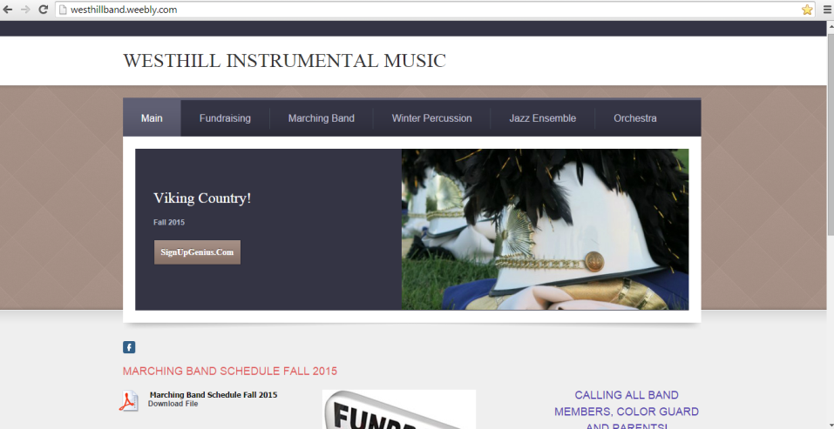
2. Scrolling down this main page allows you to see important notifications, see/download the upcoming schedule for the week (especially during competition times), links to the fundraiser page as well as links to other pages of interest (e.g. school, band organizations, etc.).  Please note, this page is CONSTANTLY changing so please bookmark and check often! | 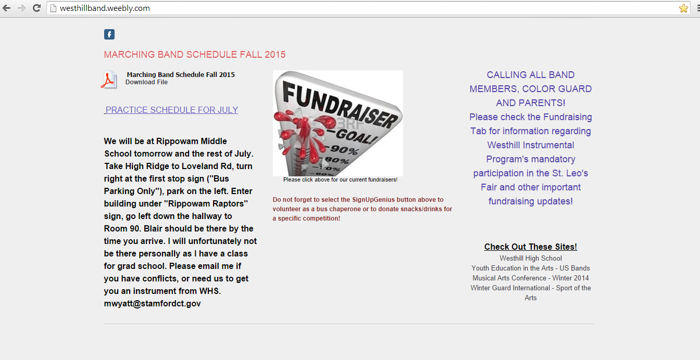
3. The ‘Main’ tab has two sub-tabs: | 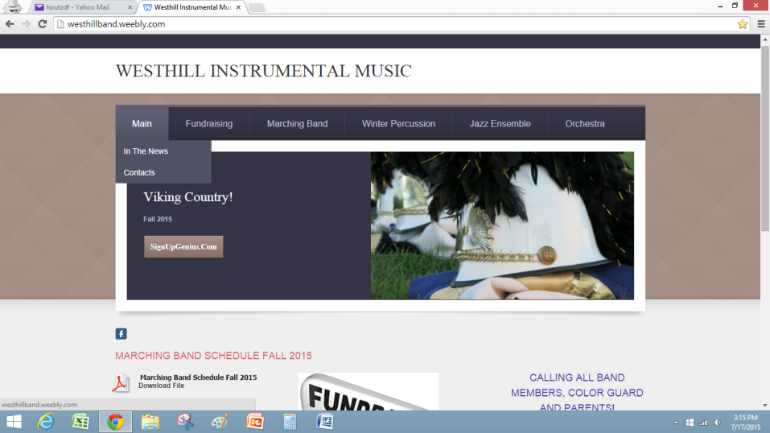
‘In the News’ which provides links to current media stories (most likely will be supplanted in the future by the Westhill Band Parents’ Facebook page)  and | 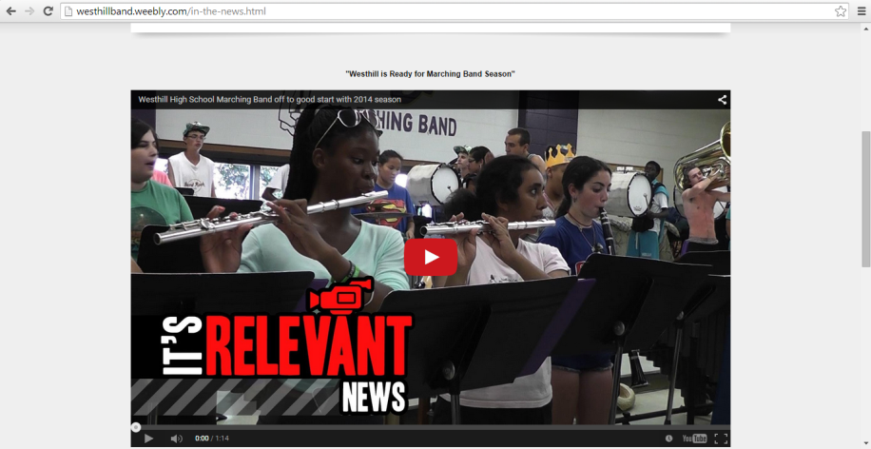
Contacts’ which provides contact information for the WHSBPA board members as well as the music director. | Hold for current copy of contact info
5. Selecting the ‘Fundraising’ tab allows viewers to see all the current and ongoing fundraising activities, as well as a brief description.  At this time, the ‘PayPal’ button is not active (reserved for future use).  As you scroll down the page, there is detail, links to forms, links to webpages for each of the various fundraisers.  Like the Main page, this tab is constantly being updated so check back frequently! | 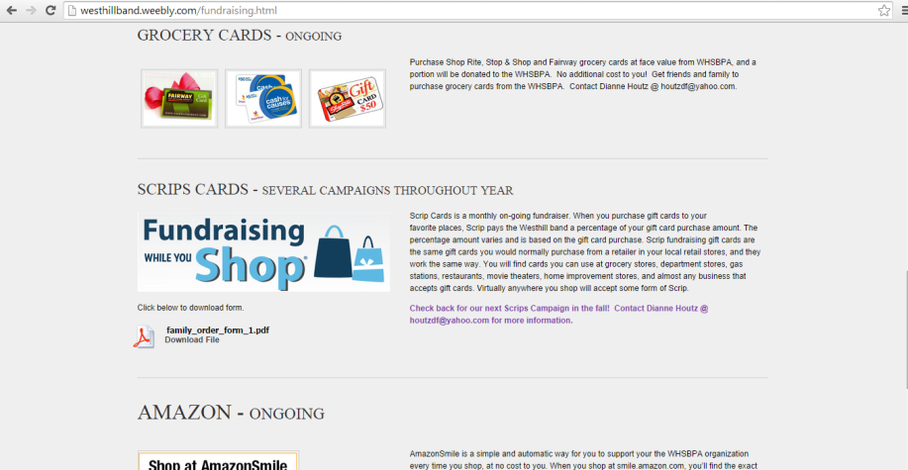  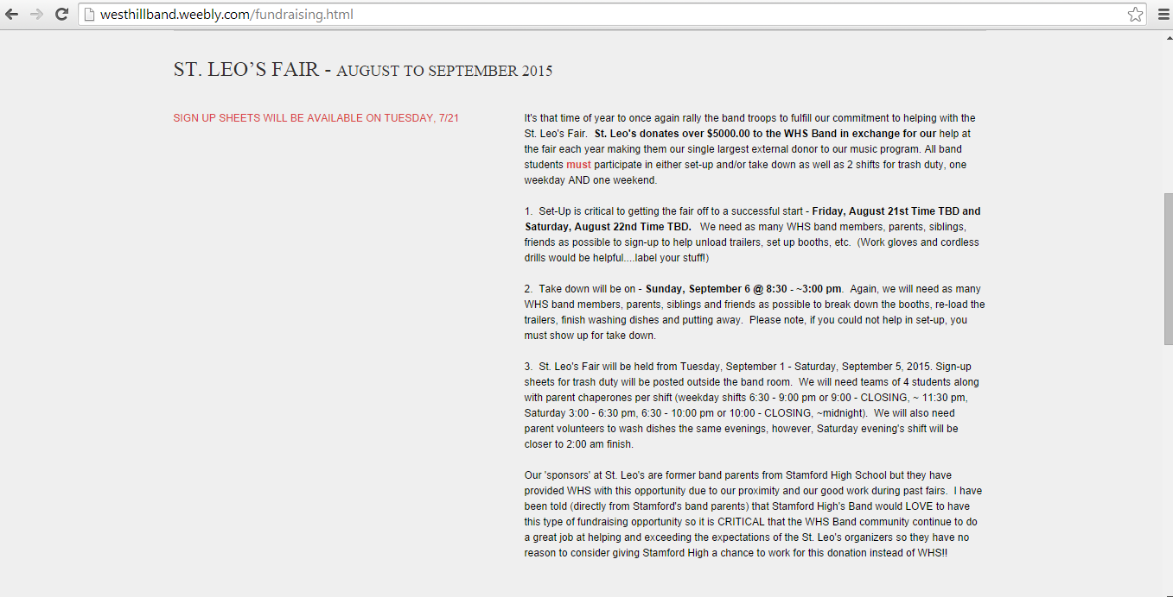  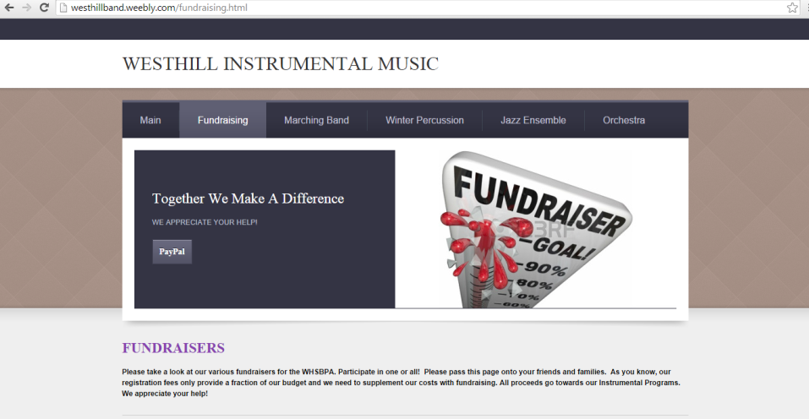
6. The ‘Marching Band’ tab is the main resource for the Marching Band program. The full calendar is visible and can be downloaded from this tab. | 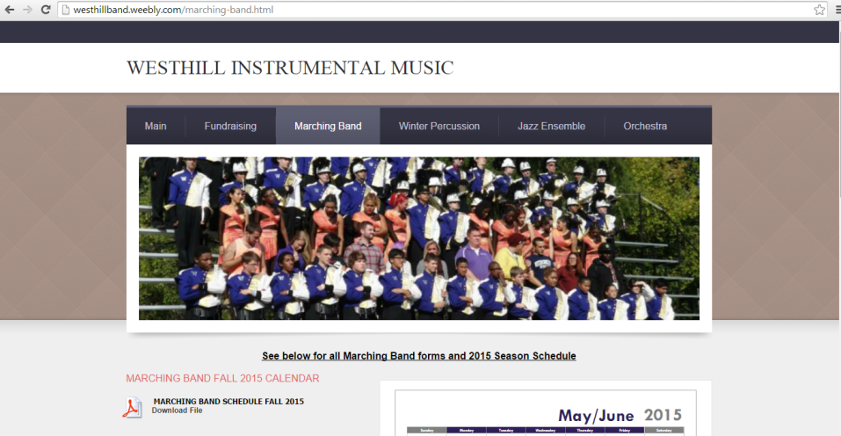
7. All of the necessary paperwork required for participation in the band program can be downloaded from this site. | 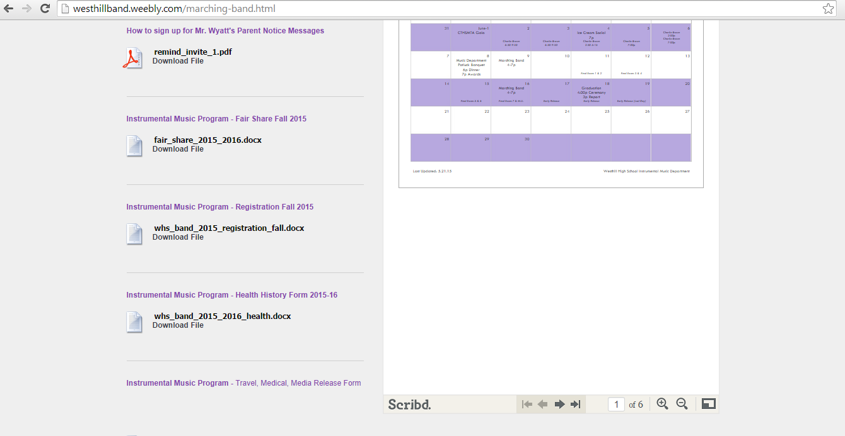
8. Although not discussed in detail, pertinent information will be listed for the other instrumental programs on their respective tabs (Winter Percussion, Jazz Ensemble, Orchestra). | 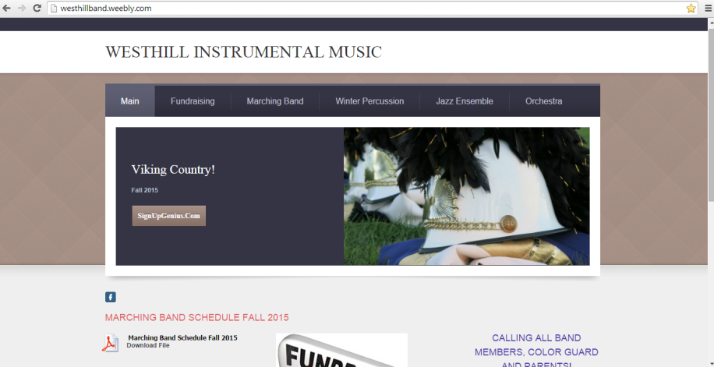

WHY FUNDRAISING MATTERS

The Westhill Band Parents Association plus Mr Wyatt’s budget from the school cover a huge amount of the costs of running the band. However, there are additional costs that we raise “general” funds to cover (e.g., not specific to a student’s name). We need high participation in these general fundraisers, so that we can keep the costs down that families are responsible for.
Westhill Instrumental Programs’ annual budget is approximately $70 to $80K
The

SPS
Student Transportation (Bus)
Instruments and Repair
Membership and Show Registration Fees
School expenses (e.g. custodial fees)
Subject to Budget

WHSBPA
Transportation (Truck)
Band Camp
Instructor Salaries
Costumes
Show & Purple T-shirts
Fundraising
St. Leo’s Fair
Tag Sale
Hosted WIP Competitions
Concert Bake Sales
Grocery Cards
Scrips
Lord & Taylor
Candy Sales

Registration
Fall Marching Band
Indoor Winter Percussio

2015/2016 FUNDRAISERS

Please note the fundraiser tab on http://westhillband.weebly.com/ has details on each of the fundraisers below!
ST. LEO’S FAIR AUG-SEPT. 2015
TAG SALE SEPT. 2015
BINGO OCTOBER 2015
CANDY SALE 2X A YEAR**
MIXED BAG SALE 2X A YEAR** (Watch for info to come home with your student!)
SCRIP CARDS 2 OR 3X A YEAR (Watch for info to come home with your student!)
SHOPRITE/STOP & SHOP CONTINUOUS (Contact Dianne Houtz)
WESTHILL HOSTS 2 WINTER PERCUSSION COMPETITIONS (USUALLY MARCH & APRIL)
BAKE SALE AT ALL MUSICAL CONCERTS (Use SignUp Genius to volunteer)

** FLAT PERCENTAGE OF WHAT STUDENT RAISES COUNTS TOWARDS REDUCING STUDENT’S BAND FEES. Other fundraisers help meet WHSBPA general budget that we use to defray total costs of the band program.
Unless otherwise noted, contact for all fundraisers is Joanie Bellantoni.

HOW TO VOLUNTEER: SignUpGenius

How to access SignUpGenius
SignUpGenius is a webpage that is utilized by the WHSBPA to enable parents to sign up for various volunteer assignments (e.g. bus chaperone, dishwasher for St. Leo’s Fair) or to indicate they are donating a requested item for an event (e.g. providing a dozen cupcakes for the Winter Concert, donating a case of water for the bus for a weekend competition). Use of this webpage allows everyone to see where gaps are and does not require user registration for the webpage. Please make sure that your contact e-mail is up-to-date.
Instructions
1. Most parents will be introduced to SignUpGenius via an e-mail from one of the WHSBPA board members.  As per the instructions, simply click on the link provided in the e-mail. | 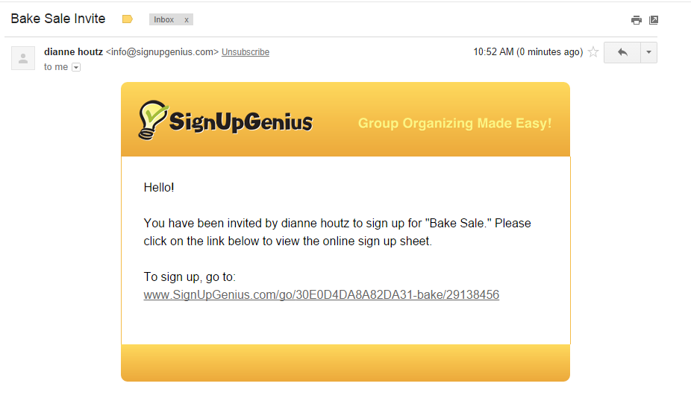
2. You will see a description of the event and what is being requested (e.g. volunteer for a specific date, donation request for specific items).
3. You may or may not have to scroll to the area where you can sign up for specific items/events. | 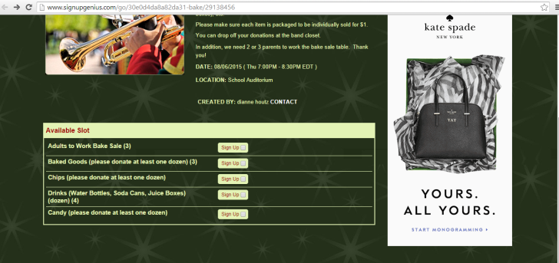
4. Check-off the items that you are volunteering for and then select the ‘Submit and Sign Up’ button at the bottom of the screen. | 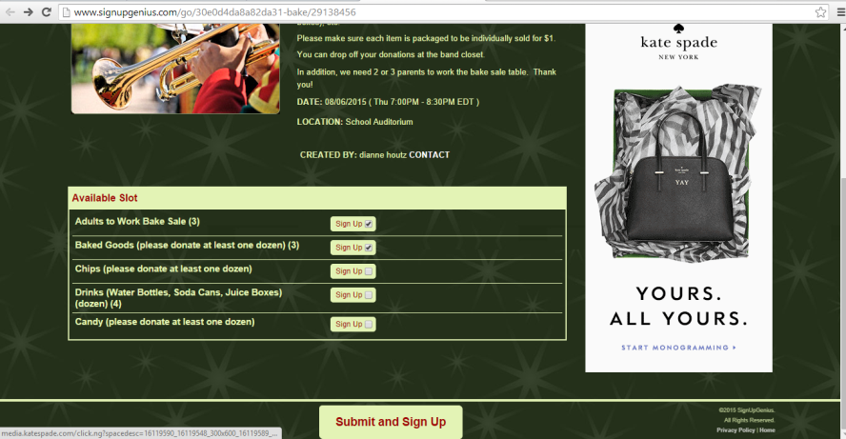
5. You will now see the specific items that you are planning to sign up for. You can change quantity (e.g. you can volunteer 3 people for an event; you can bring 2 dozen cupcakes) or you can even sign up on behalf of someone who is not currently associated with the band (e.g. sign up in-law to volunteer). | 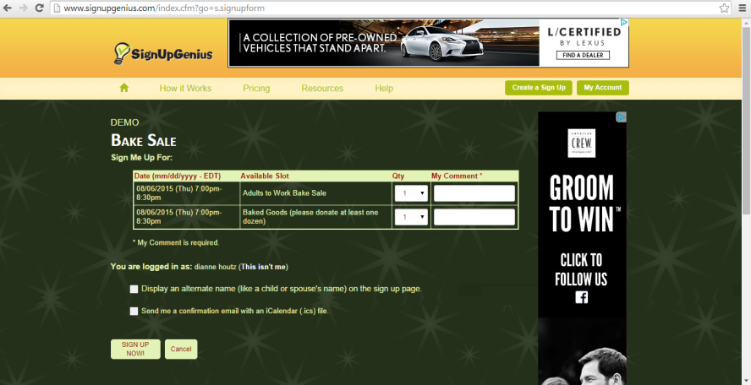
6. Once you have made modifications/comments, select the ‘Sign Up Now!’ button at the lower left to finish. | 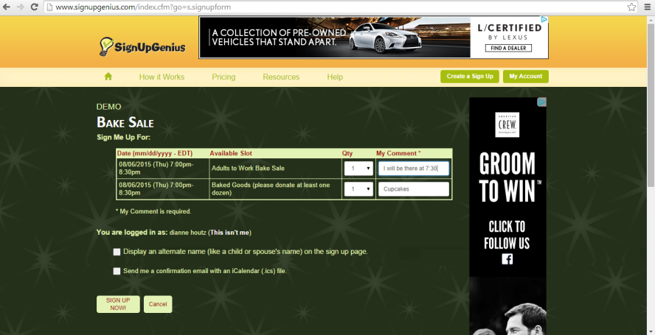
7. You will see a confirmation page of what and when you have signed up for. | 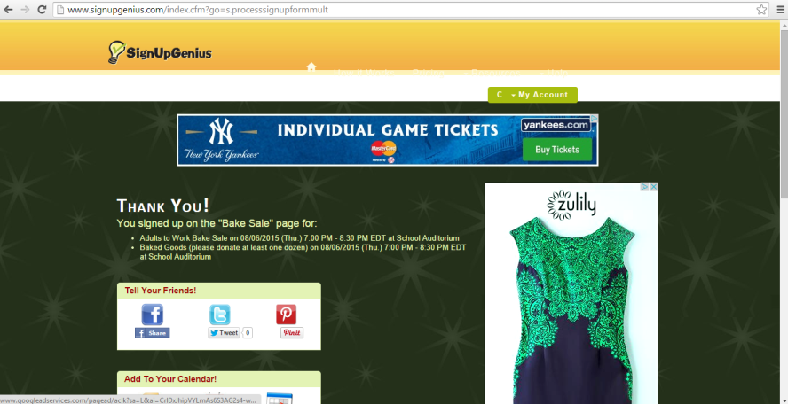
8. You will also receive a confirmation e-mail (similar to your invite e-mail) confirming what you have signed up for. Simply select the link in the e-mail and you will be brought back to the following page where you can modify or delete your response. | 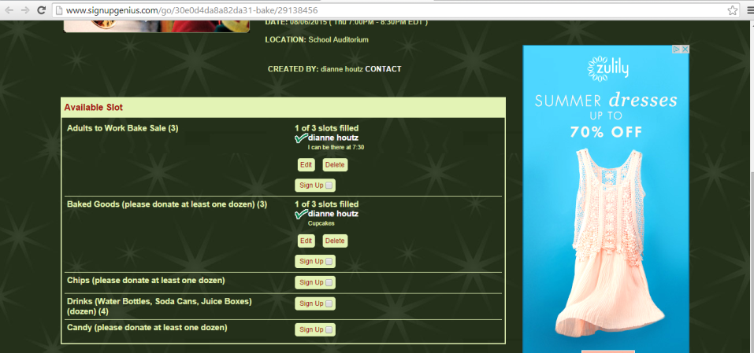
9. Alternatively, you can access SignUpGenius by accessing http://www.signupgenius.com/ or by selecting the SignUpGenius via the Westhill Instrumental Music webpage. | 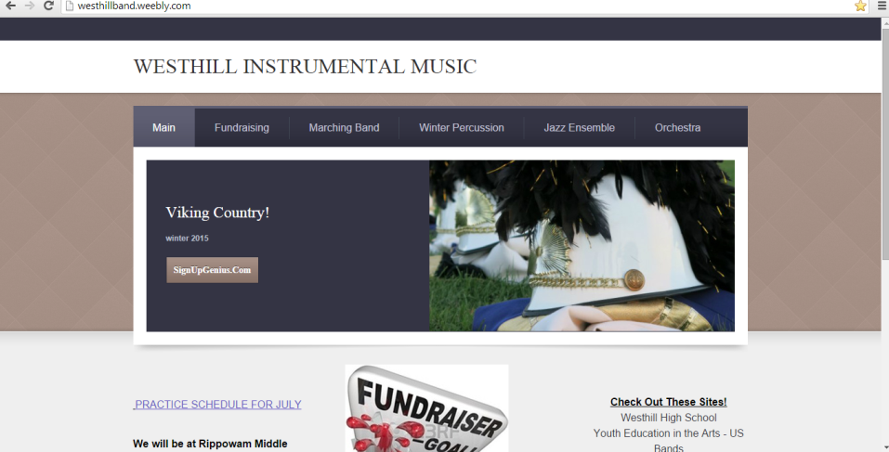
10. If you access the application this way (not via an e-mail link), you will need to create a member ID (your e-mail) and a password. Select the ‘Login/Join’ button in the upper right of the screen to complete this quick registration.
11. However, if you do register for the application, you will be able to view all the sign ups that you have signed up for AND all the invitations that you have been sent which could allow you to make changes (e.g. change as a bus volunteer from one weekend to another). | 