How to access the Westhill Instrumental Programs’ Webpage
The Westhill Instrumental Program’s webpage is a webpage created by a band parent (Brian Gasser) that is utilized by the WHSBPA and the music director to get the most updated information on any of the Instrumental Programs, e.g. important notifications schedules, current fundraisers, forms contact info and other pertinent information needed to run a program. Registration is not required to use this webpage and it is accessible via mobile phone or computer. Please note, this page is CONSTANTLY changing and is utilized for all the instrumental programs (including school musicals/plays as we have so many students participating in multiple programs) so please bookmark the site and check often!
Instructions
1. Access the webpage via the following address:  http://westhillband.weebly.com/  You will be brought to the main page which provides navigation tabs to each of Westhill’s music programs. In addition there is a button which will get you to to Sign-Up Genius, used by the WHSBPA for volunteer assignments. Finally, there is a Facebook link that goes directly to the Westhill Band Parents Facebook page (closed group, please request to join). | 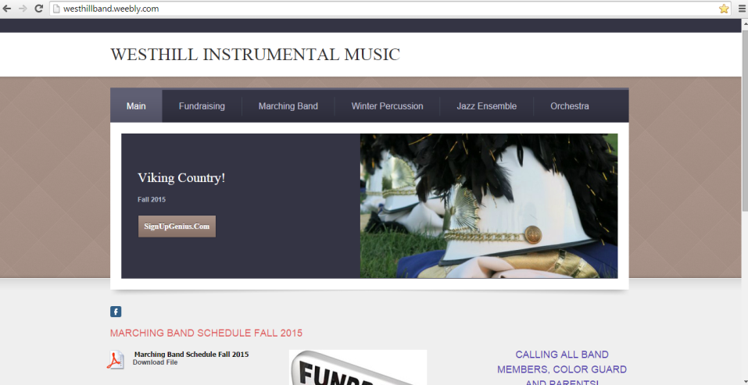
2. Scrolling down this main page allows you to see important notifications, see/download the upcoming schedule for the week (especially during competition times), links to the fundraiser page as well as links to other pages of interest (e.g. school, band organizations, etc.).  Please note, this page is CONSTANTLY changing so please bookmark and check often! | 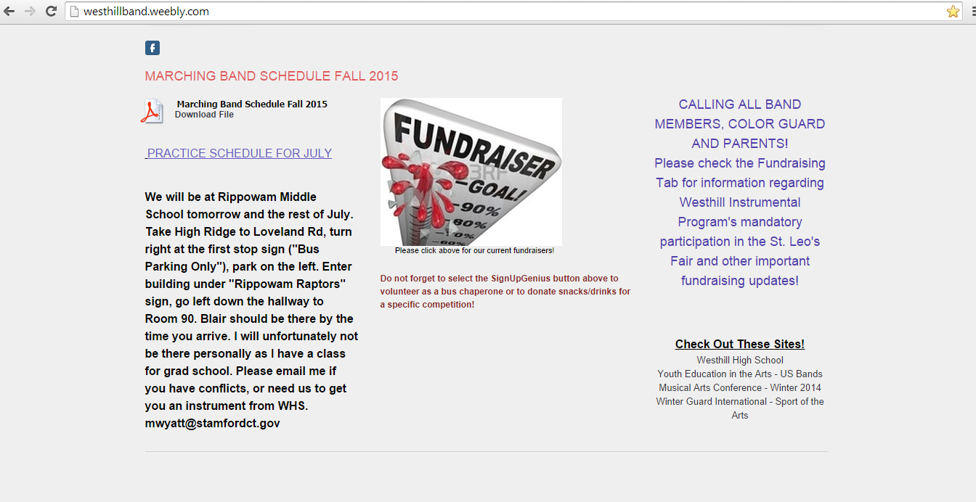
3. The ‘Main’ tab has two sub-tabs: | 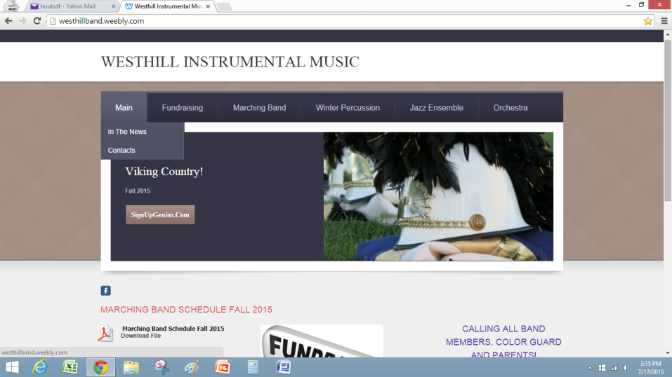
‘In the News’ which provides links to current media stories (most likely will be supplanted in the future by the Westhill Band Parents’ Facebook page)  and | 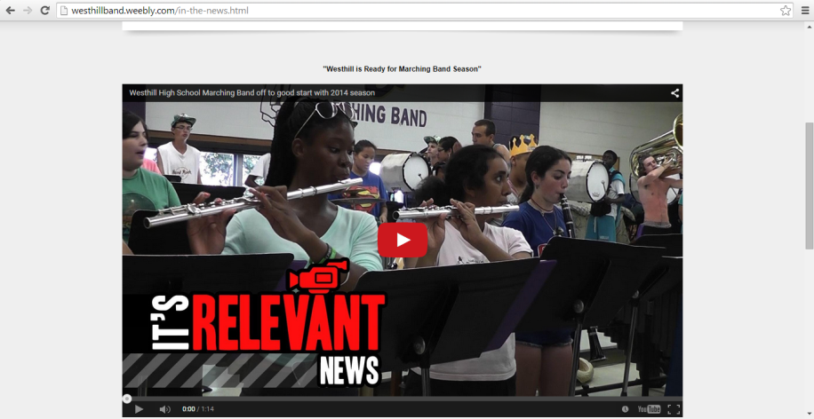
Contacts’ which provides contact information for the WHSBPA board members as well as the music director. | Hold for current copy of contact info
5. Selecting the ‘Fundraising’ tab allows viewers to see all the current and ongoing fundraising activities, as well as a brief description.  At this time, the ‘PayPal’ button is not active (reserved for future use).  As you scroll down the page, there is detail, links to forms, links to webpages for each of the various fundraisers.  Like the Main page, this tab is constantly being updated so check back frequently! | 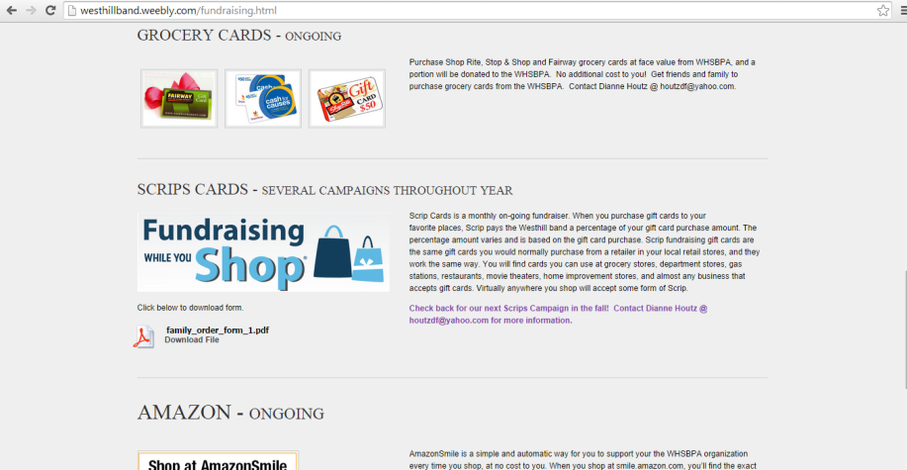  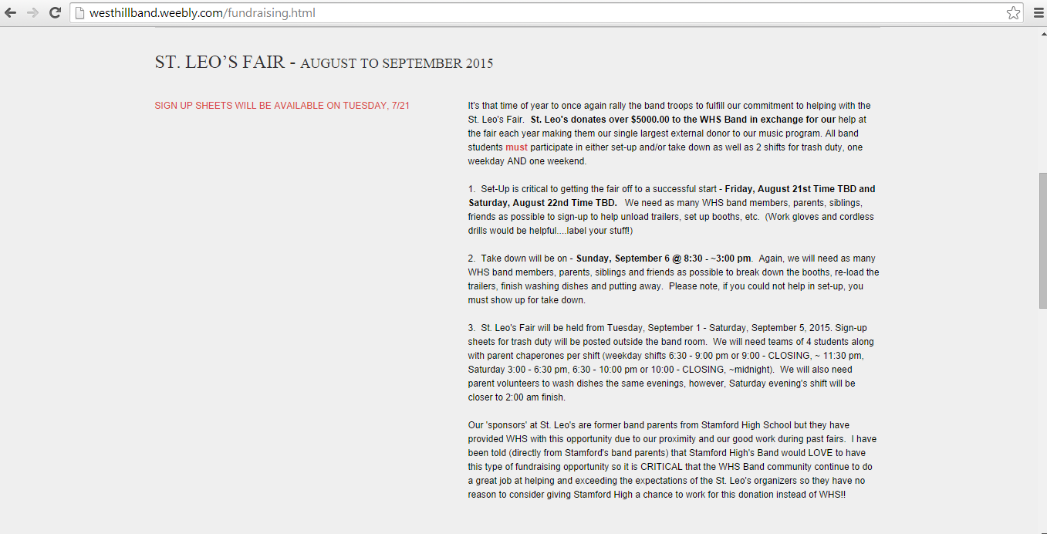  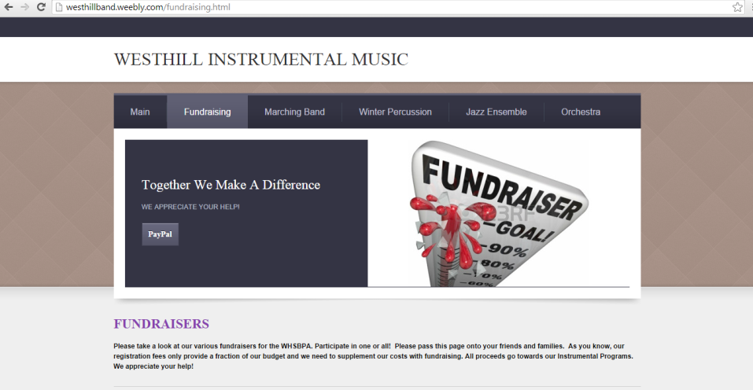
6. The ‘Marching Band’ tab is the main resource for the Marching Band program. The full calendar is visible and can be downloaded from this tab. | 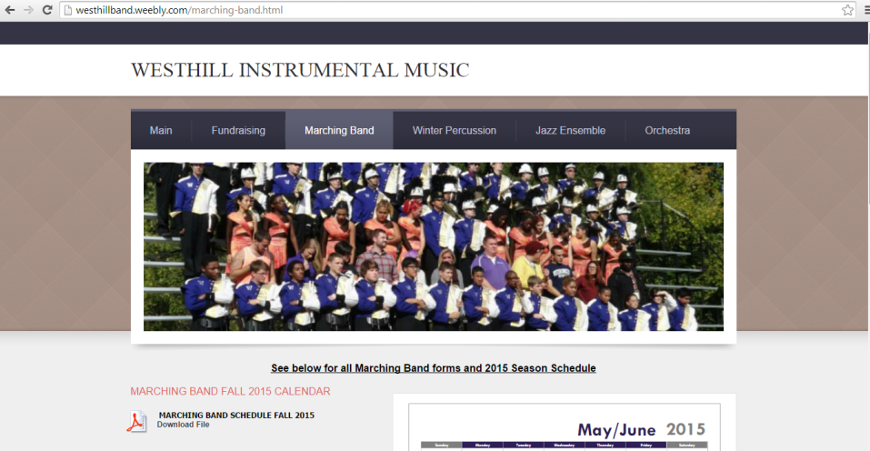
7. All the necessary paperwork required for participation in the band program can be downloaded from this site. | 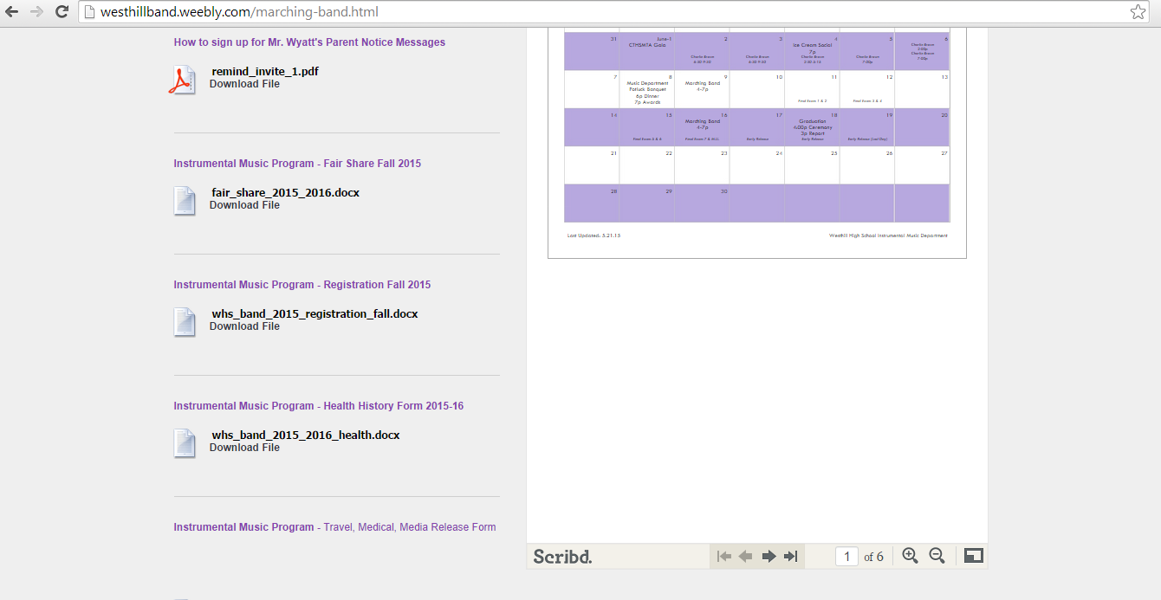
8. Although not discussed in detail, pertinent information will be listed for the other instrumental programs on their respective tabs (Winter Percussion, Jazz Ensemble, Orchestra). | 